Covid19 Analysis

Numrah Alauddin

12/10/2021

#Library Defined  
  
knitr::opts_chunk$set(error = TRUE)  
library(Hmisc)

## Loading required package: lattice

## Loading required package: survival

## Loading required package: Formula

## Loading required package: ggplot2

##   
## Attaching package: 'Hmisc'

## The following objects are masked from 'package:base':  
##   
## format.pval, units

library(factoextra)

## Warning: package 'factoextra' was built under R version 4.1.2

## Welcome! Want to learn more? See two factoextra-related books at https://goo.gl/ve3WBa

library(dplyr)

## Warning: package 'dplyr' was built under R version 4.1.2

##   
## Attaching package: 'dplyr'

## The following objects are masked from 'package:Hmisc':  
##   
## src, summarize

## The following objects are masked from 'package:stats':  
##   
## filter, lag

## The following objects are masked from 'package:base':  
##   
## intersect, setdiff, setequal, union

#File that have been called for the data  
  
data <- read.csv("C:/Users/ARSALAN IQBAL/Downloads/COVID19_line_list_data.csv")  
data <- select(data,-c(X.1:X.6))  
data <- select(data,-c(X))  
data_copied <- data  
describe(data)

## data   
##   
## 20 Variables 1085 Observations  
## --------------------------------------------------------------------------------  
## ï..id   
## n missing distinct Info Mean Gmd .05 .10   
## 1085 0 1085 1 543 362 55.2 109.4   
## .25 .50 .75 .90 .95   
## 272.0 543.0 814.0 976.6 1030.8   
##   
## lowest : 1 2 3 4 5, highest: 1081 1082 1083 1084 1085  
## --------------------------------------------------------------------------------  
## case_in_country   
## n missing distinct Info Mean Gmd .05 .10   
## 888 197 197 1 48.84 54.99 2.00 4.00   
## .25 .50 .75 .90 .95   
## 11.00 28.00 67.25 110.30 153.65   
##   
## lowest : 1 2 3 4 5, highest: 365 443 875 925 1443  
##   
## Value 0 20 40 60 80 100 120 140 160 180 200  
## Frequency 215 241 137 81 84 40 22 19 22 19 1  
## Proportion 0.242 0.271 0.154 0.091 0.095 0.045 0.025 0.021 0.025 0.021 0.001  
##   
## Value 280 300 360 440 880 920 1440  
## Frequency 1 1 1 1 1 1 1  
## Proportion 0.001 0.001 0.001 0.001 0.001 0.001 0.001  
##   
## For the frequency table, variable is rounded to the nearest 20  
## --------------------------------------------------------------------------------  
## reporting.date   
## n missing distinct   
## 1084 1 43   
##   
## lowest : 02/01/20 02/02/20 02/03/20 02/04/20 02/05/20   
## highest: 2/24/2020 2/25/2020 2/26/2020 2/27/2020 2/28/2020  
## --------------------------------------------------------------------------------  
## summary   
## n missing distinct   
## 1080 5 967   
##   
## lowest : confirmed COVID-19 pneumonia patient No.11 in Tianjin: female, 55, symptom onset on 01/23/2020, hospitalized on 01/23/2020, confirmed on 01/26/2020 confirmed COVID-19 pneumonia patient No.12 in Tianjin: female, 79, symptom onset on 01/24/2020, hospitalized on 01/24/2020, confirmed on 01/26/2020 confirmed COVID-19 pneumonia patient No.13 in Tianjin: female, 19, symptom onset on 01/19/2020, hospitalized on 01/20/2020, confirmed on 01/26/2020 confirmed COVID-19 pneumonia patient No.14 in Tianjin: male, 71, Wuhan resident, visited Malaysia from 01/19/2020 to 01/25/2020, arrived in Tianjin on 01/25/2020, symptom onset on 01/25/2020, hospitalized on 01/25/2020, confirmed on 01/26/2020 confirmed imported COVID-19 pneumonia patient in Gansu: female, 20, lives in Wuhan, arrived in Gansu on 01/18/2020, symptom onset on 01/19/2020, visit clinic on 01/24/2020, hospitalized on 01/24/2020.   
## highest: new recovered imported COVID-19 pneumonia patient in Beijing: female, returned to Beijing from Wuhan on 01/08/2020, symptom onset afterwards, recovered on 01/24/2020. new recovered imported COVID-19 pneumonia patient in Beijing: male, returned to Beijing from Wuhan on 01/08/2020, symptom onset afterwards, recovered on 01/25/2020. Second confirmed imported COVID-19 pneumonia patient in Guangxi: male, 46, in contact with individuals from Wuhan before symptom onset. symptom onset on 01/20/2020. Second confirmed imported COVID-19 pneumonia patient in Liaoning: male, 40, works in Wuhan, visit Fushun, Liaoning on 01/12/2020, symptom onset on 01/14/2020, visit clinic in Fushun Dalian on 01/19/2020. Second confirmed imported COVID-19 pneumonia patient in Sichuan: male, 57, Wuhan resident, visited Sichuan on 01/15/2020, symptom onset on 01/16/2020 and hospitalized.   
## --------------------------------------------------------------------------------  
## location   
## n missing distinct   
## 1085 0 156   
##   
## lowest : Afghanistan Aichi Prefecture Alappuzha Algeria Amiens   
## highest: Yunnan Zabaikalsky Zaragoza Zhejiang Zhuhai   
## --------------------------------------------------------------------------------  
## country   
## n missing distinct   
## 1085 0 38   
##   
## lowest : Afghanistan Algeria Australia Austria Bahrain   
## highest: Thailand UAE UK USA Vietnam   
## --------------------------------------------------------------------------------  
## gender   
## n missing distinct   
## 902 183 2   
##   
## Value female male  
## Frequency 382 520  
## Proportion 0.424 0.576  
## --------------------------------------------------------------------------------  
## age   
## n missing distinct Info Mean Gmd .05 .10   
## 843 242 85 0.999 49.48 20.79 22.0 25.0   
## .25 .50 .75 .90 .95   
## 35.0 51.0 64.0 75.0 78.9   
##   
## lowest : 0.25 0.50 1.00 2.00 4.00, highest: 86.00 87.00 89.00 91.00 96.00  
## --------------------------------------------------------------------------------  
## symptom_onset   
## n missing distinct   
## 563 522 70   
##   
## lowest : 01/02/20 01/03/20 01/04/20 01/05/20 01/06/20   
## highest: 2/22/2020 2/23/2020 2/24/2020 2/25/2020 2/26/2020  
## --------------------------------------------------------------------------------  
## If_onset_approximated   
## n missing distinct Info Sum Mean Gmd   
## 560 525 2 0.123 24 0.04286 0.08219   
##   
## --------------------------------------------------------------------------------  
## hosp_visit_date   
## n missing distinct   
## 507 578 60   
##   
## lowest : 01/01/20 01/03/20 01/05/20 01/06/20 01/08/20   
## highest: 2/24/2020 2/25/2020 2/26/2020 2/27/2020 2/28/2020  
## --------------------------------------------------------------------------------  
## exposure_start   
## n missing distinct   
## 128 957 39   
##   
## lowest : 01/03/20 01/06/20 01/08/20 01/09/20 01/10/20   
## highest: 2/15/2020 2/17/2020 2/19/2020 2/20/2020 2/21/2020  
## --------------------------------------------------------------------------------  
## exposure_end   
## n missing distinct   
## 341 744 52   
##   
## lowest : 01/02/20 01/03/20 01/04/20 01/05/20 01/06/20   
## highest: 2/21/2020 2/22/2020 2/23/2020 2/24/2020 2/25/2020  
## --------------------------------------------------------------------------------  
## visiting.Wuhan   
## n missing distinct Info Sum Mean Gmd   
## 1085 0 2 0.437 192 0.177 0.2916   
##   
## --------------------------------------------------------------------------------  
## from.Wuhan   
## n missing distinct Info Sum Mean Gmd   
## 1081 4 2 0.37 156 0.1443 0.2472   
##   
## --------------------------------------------------------------------------------  
## death   
## n missing distinct   
## 1085 0 14   
##   
## lowest : 0 02/01/20 1 2/13/2020 2/14/2020  
## highest: 2/24/2020 2/25/2020 2/26/2020 2/27/2020 2/28/2020  
##   
## 0 (1022, 0.942), 02/01/20 (1, 0.001), 1 (42, 0.039), 2/13/2020 (1, 0.001),  
## 2/14/2020 (1, 0.001), 2/19/2020 (2, 0.002), 2/21/2020 (2, 0.002), 2/22/2020 (1,  
## 0.001), 2/23/2020 (4, 0.004), 2/24/2020 (1, 0.001), 2/25/2020 (2, 0.002),  
## 2/26/2020 (3, 0.003), 2/27/2020 (2, 0.002), 2/28/2020 (1, 0.001)  
## --------------------------------------------------------------------------------  
## recovered   
## n missing distinct   
## 1085 0 32   
##   
## lowest : 0 02/02/20 02/04/20 02/05/20 02/06/20   
## highest: 2/24/2020 2/25/2020 2/26/2020 2/27/2020 2/28/2020  
## --------------------------------------------------------------------------------  
## symptom   
## n missing distinct   
## 270 815 108   
##   
## lowest : chest discomfort chills cold, fever, pneumonia cough cough with sputum   
## highest: throat pain, chills throat pain, fever tired vomiting, cough, fever, sore throat vomiting, diarrhea, fever, cough   
## --------------------------------------------------------------------------------  
## source   
## n missing distinct   
## 1085 0 85   
##   
## lowest : å¤®è§†æ–°é—» ABC ABC News æ–°æµª Al Arabiya   
## highest: Wa.de Washington Examiner Xin Hua Net Yahoo News Yonnhap News Agency  
## --------------------------------------------------------------------------------  
## link   
## n missing distinct   
## 1085 0 490   
##   
## lowest : http://behdasht.gov.ir/news/%DA%A9%D8%B1%D9%88%D9%86%D8%A7+%D9%88%DB%8C%D8%B1%D9%88%D8%B3/199807/%D8%AF%D8%B1+%D8%B1%D9%88%D8%B2%D9%87%D8%A7%DB%8C+%DA%AF%D8%B0%D8%B4%D8%AA%D9%87+735+%D8%A8%DB%8C%D9%85%D8%A7%D8%B1+%D8%A8%D8%A7+%D8%B9%D9%84%D8%A7%D8%A6%D9%85+%D8%B4%D8%A8%D9%87+%D8%A2%D9%86%D9%81%D9%84%D9%88%D8%A2%D9%86%D8%B2%D8%A7+%D8%AF%D8%B1+%DA%A9%D8%B4%D9%88%D8%B1+%D8%A8%D8%B3%D8%AA%D8%B1%DB%8C+%D8%B4%D8%AF%D9%86%D8%AF+%D8%A8%D8%B1+%D8%A7%D8%B3%D8%A7%D8%B3+%D8%A2%D8%AE%D8%B1%DB%8C%D9%86+%D9%86%D8%AA%D8%A7%DB%8C%D8%AC+%D8%A2%D8%B2%D9%85%D8%A7%DB%8C%D8%B4+%D9%87%D8%A7+%D8%A7%D8%A8%D8%AA%D9%84%D8%A7%DB%8C+13+%D9%85%D9%88%D8%B1%D8%AF+%D8%AF%DB%8C%DA%AF%D8%B1+%D8%A8%D9%87+%DA%A9%D9%88%D9%88%DB%8C%D8%AF19+%D9%82%D8%B7%D8%B9%DB%8C+%D8%A8%D9%87+%D9%86%D8%B8%D8%B1+%D9%85%DB%8C+%D8%B1%D8%B3%D8%AF http://english.alarabiya.net/en/News/gulf/2020/02/25/Number-of-Kuwait-coronavirus-cases-rises-to-eight-KUNA.html http://sxwjw.shaanxi.gov.cn/art/2020/1/27/art_9_67483.html http://wjw.beijing.gov.cn/xwzx_20031/wnxw/202001/t20200121_1620353.html http://wjw.sz.gov.cn/wzx/202001/t20200120_18987787.htm   
## highest: https://www3.nhk.or.jp/nhkworld/en/news/20200116_23/ https://www3.nhk.or.jp/nhkworld/en/news/20200124_14/ https://www3.nhk.or.jp/nhkworld/en/news/20200126_31/ https://www3.nhk.or.jp/nhkworld/en/news/20200130_02/ https://www3.nhk.or.jp/nhkworld/en/news/20200131_01/   
## --------------------------------------------------------------------------------

data_copied$death_dummy <- as.integer(data$death !=0)  
data_copied <- select(data_copied,-c(2,9,10,11,12,13,18,19))  
data_copied <- na.omit(data_copied)  
summary(data_copied)

## ï..id reporting.date summary location   
## Min. : 1 Length:821 Length:821 Length:821   
## 1st Qu.: 240 Class :character Class :character Class :character   
## Median : 450 Mode :character Mode :character Mode :character   
## Mean : 469   
## 3rd Qu.: 682   
## Max. :1085   
## country gender age visiting.Wuhan   
## Length:821 Length:821 Min. : 0.50 Min. :0.0000   
## Class :character Class :character 1st Qu.:35.00 1st Qu.:0.0000   
## Mode :character Mode :character Median :51.00 Median :0.0000   
## Mean :49.82 Mean :0.1778   
## 3rd Qu.:64.00 3rd Qu.:0.0000   
## Max. :96.00 Max. :1.0000   
## from.Wuhan death recovered link   
## Min. :0.0000 Length:821 Length:821 Length:821   
## 1st Qu.:0.0000 Class :character Class :character Class :character   
## Median :0.0000 Mode :character Mode :character Mode :character   
## Mean :0.1827   
## 3rd Qu.:0.0000   
## Max. :1.0000   
## death_dummy   
## Min. :0.00000   
## 1st Qu.:0.00000   
## Median :0.00000   
## Mean :0.07065   
## 3rd Qu.:0.00000   
## Max. :1.00000

Comment:

#Deaths of the patients  
  
death_all = subset(data_copied,death_dummy == 1)  
hist(death_all$age, col='maroon',main='Deaths Female Covid Effecties w.r.t Age',xlab="Age")

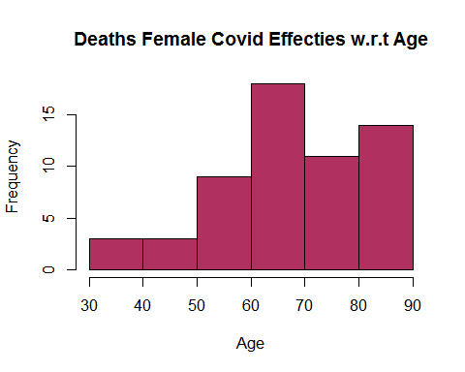

#Gender wise Deaths (Male)  
  
men <- subset(data_copied, gender == "male")  
mendeath <- subset(men,death_dummy == 1)  
hist(mendeath$age, col='brown',main='Deaths of Male Covid Effecties w.r.t Age',xlab="Age")

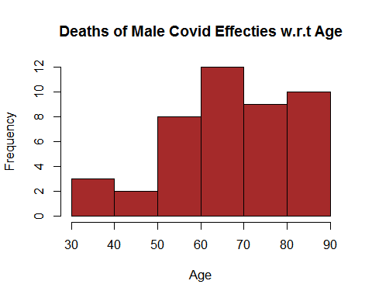 Comment:

#Gender wise Deaths (Female)  
  
women <- subset(data_copied, gender == "female")  
womendeath <- subset(women,death_dummy == 1)  
hist(womendeath$age, col='light blue',main='Deaths of Female Covid Effecties w.r.t Age',xlab="Age")

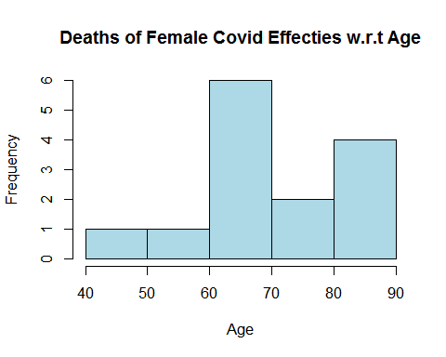 Comment:

#Called Principle Component Analysis on our data  
  
head(data_copied)

## ï..id reporting.date  
## 1 1 1/20/2020  
## 2 2 1/20/2020  
## 3 3 1/21/2020  
## 4 4 1/21/2020  
## 5 5 1/21/2020  
## 6 6 1/21/2020  
## summary  
## 1 First confirmed imported COVID-19 pneumonia patient in Shenzhen (from Wuhan): male, 66, shenzheng residence, visited relatives in Wuhan on 12/29/2019, symptoms onset on 01/03/2020, returned to Shenzhen and seek medical care on 01/04/2020, hospitalized on 01/11/2020, sample sent to China CDC for testing on 01/18/2020, confirmed on 01/19/2020. 8 others under medical observation, contact tracing ongoing.  
## 2 First confirmed imported COVID-19 pneumonia patient in Shanghai (from Wuhan): female, 56, Wuhan residence, arrived in Shanghai from Wuhan on 01/12/2020, symptom onset and visited fever clinic on 01/15/2020, laboratory confirmed on 01/20/2020  
## 3 First confirmed imported cases in Zhejiang: patient is male, 46, lives in Wuhan, self-driving from Wuhan to Hangzhou on 01/03/2020, symptom onset 01/04/2020, hospitalized on 01/17/2020, sample deliver to China CDC for testing on 01/20/2020, test positive on 01/21/2020.  
## 4 new confirmed imported COVID-19 pneumonia in Tianjin: female, age 60, recently visited Wuhan, visited fever clinic on 01/19/2020 in Tianjin then quarantined immediately.  
## 5 new confirmed imported COVID-19 pneumonia in Tianjin: male, age 58, visited fever clinic on 01/14/2020.  
## 6 First confirmed imported COVID-19 pneumonia patient in Chongqing (from Wuhan): female, age 44, symptoms onset on 01/15/2020, laboratory confirmed on 01/21/2020.  
## location country gender age visiting.Wuhan from.Wuhan death  
## 1 Shenzhen, Guangdong China male 66 1 0 0  
## 2 Shanghai China female 56 0 1 0  
## 3 Zhejiang China male 46 0 1 0  
## 4 Tianjin China female 60 1 0 0  
## 5 Tianjin China male 58 0 0 0  
## 6 Chongqing China female 44 0 1 0  
## recovered  
## 1 0  
## 2 0  
## 3 0  
## 4 0  
## 5 0  
## 6 0  
## link  
## 1 http://wjw.sz.gov.cn/wzx/202001/t20200120_18987787.htm  
## 2 https://www.weibo.com/2372649470/IqogQhgfa?from=page_1001062372649470_profile&wvr=6&mod=weibotime&type=comment  
## 3 http://www.zjwjw.gov.cn/art/2020/1/21/art_1202101_41786033.html  
## 4 https://m.weibo.cn/status/4463235401268457?  
## 5 https://m.weibo.cn/status/4463235401268457?  
## 6 http://wsjkw.cq.gov.cn/tzgg/20200121/249730.html  
## death_dummy  
## 1 0  
## 2 0  
## 3 0  
## 4 0  
## 5 0  
## 6 0

data_copiedpc <- data_copied[,c(7,8,9)]  
pc.data <- princomp(data_copiedpc, cor = TRUE)  
screeplot(pc.data,type="l", main="Screeplot for the Covid Data")  
abline(1,0,col= 'red',lty=2)

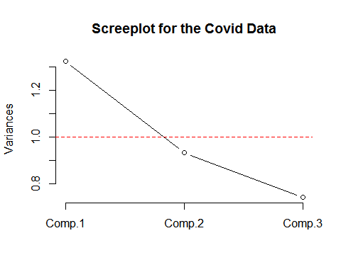

Comment:

#Regression and Data Validation  
  
death_dummy <- as.integer(data$death !=0)  
plot(data_copied$age,data_copied$death_dummy,main="Data Validation",xlab = "Age",ylab = "Probability")

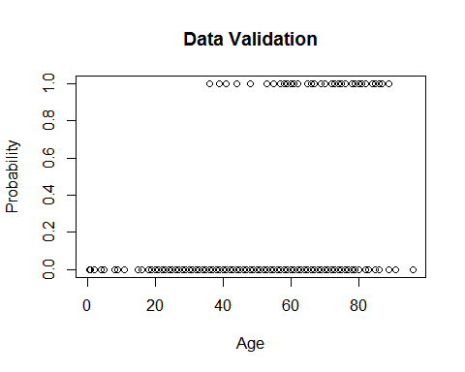

Comment:

#Clustering of Age, From Wuhan, Visiting Wuhan and Deaths  
  
data_ultra <- select(data_copied,-c(1,2,3,4,5,6,10,11,12))  
data_ultra <- na.omit(data_ultra)  
km <- kmeans(data_ultra, centers = 5, nstart = 100)  
fviz_cluster(km, data = data_ultra)

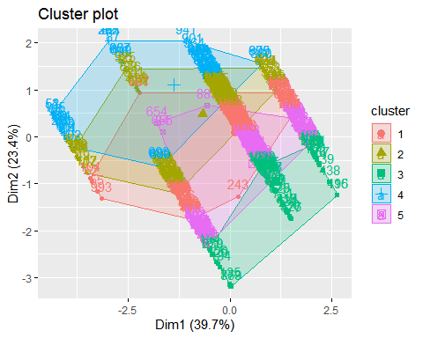

Comment: